## **Project Appendices**

### **A. Risk Log (Current)**

**Our top 3 risks are highlighted in bold.**

| **Risk ID** | **Risk Description** | **Likelihood** | **Impact** | **Owner** | **Mitigation Strategy** | **Next Check (date)** |
| --- | --- | --- | --- | --- | --- | --- |
| **R-01** | Data Integrity: Hotel/bus data from local vendors is inaccurate or out of date. | High | High | Team | Implement a "Verified" badge or Start with manual verification. | Oct 31, 2025 |
| **R-02** | User Adoption: Travelers are already accustomed to using global giants (e.g., Google Maps). | High | Medium | Team | Focus on a niche, high-trust experience. "Find a Local" and "Verified" features are key differentiators. | Nov 7, 2025 |
| **R-03** | Technical Complexity: Dynamic pricing and real-time availability are complex to build. | Medium | High | Team | De-risk with a spike (complete). Pivot to "Request to Book" (non-instant) flow for the MVP. | Oct 28, 2025 |
| **R-04** | Scope Creep: Team tries to add too many features (flights, tours, social) too early. | Medium | High | Team | Stick to the MoSCoW framework and a ruthless 3-week sprint plan focused on the core problems. | Oct 29, 2025 |

### **B. Change Log (To Date)**

| **Date** | **Change Description** | **Reason for Change** | **Decision Owner** |
| --- | --- | --- | --- |
| **Oct 22, 2025** | Solidified 3-week sprint plan (W9-11) to focus on: 1. UI Polish, 2. Bus Booking, 3. Find a Local. | Aligns sprint goals with midterm demo feedback and core user problems. | Team |
| **Oct 22, 2025** | Refined demo plan to be a simple, 3-click flow: Click Lodging -> Select Hotel -> Click Booking. | Feedback that the original demo plan was too complex for a short presentation. | Team |
| **Oct 20, 2025** | Initial project scope defined. | Finalized MoSCoW framework and validated core user problem. | Team |

### **C. Backlog Snapshot (Current)**

**Link to Live Backlog:** [[SajiloYatraBackLog.xlsx](https://docs.google.com/spreadsheets/d/1bIOVs-C2Ku6nqbRDDS5eE9tBGz-szRbw/edit?gid=2122419508#gid=2122419508)]

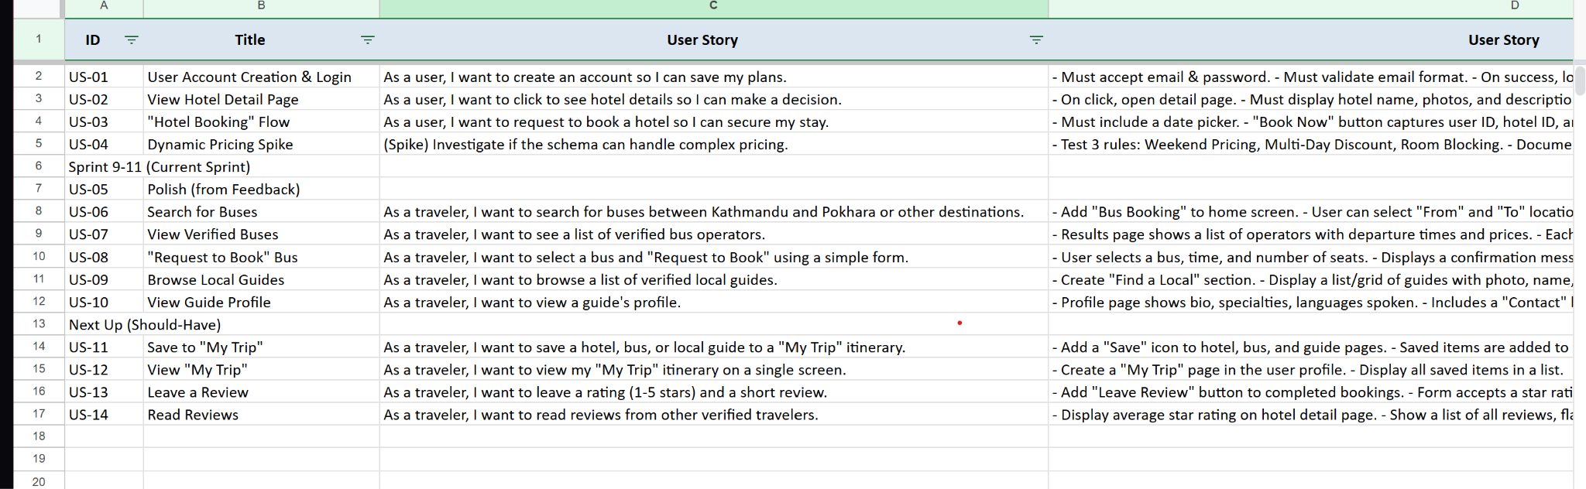

#### **To Do (Sprint 9-11)**

* **User Story:** As a traveler, I want to book a bus from Kathmandu to Pokhara...
* **User Story:** As a traveler, I want to find a local guide...
* **Task:** Implement UI/UX polish from prototype feedback (e.g., larger tap targets).
* **Task:** Create a simple onboarding screen.
* **Task:** Dynamic Pricing & Availability Simulation
* **User Story:** As a user, I want to see my profile...
* **User Story:** As a user, I want to save a hotel to a "My Trip" list...

#### **Doing (This Week)**

* **Task:** Finalize demo test plan and run all critical path tests.
* **Task:** Create README.md and .env.example for repo submission.
* **Task:** Build final slide deck PDF with all appendices.

#### **Done (Completed for Midterm)**

* **Feature:** User Account Creation & Login
* **Feature:** View Hotel Detail Page
* **Feature:** "Request to Book" Flow for Hotels (Dummy Data)
* **Doc:** Initial MoSCoW Framework
* **Doc:** Architecture Diagram